|  |  |
| --- | --- |
| **SQL CASE STUDY 1: Tiny shop**  Jermaine Sangiwa |  |

# **QUESTION 1: WHICH PRODUCT HAS THE HIGHEST PRICE? ONLY RETURN A SINGLE ROW.**

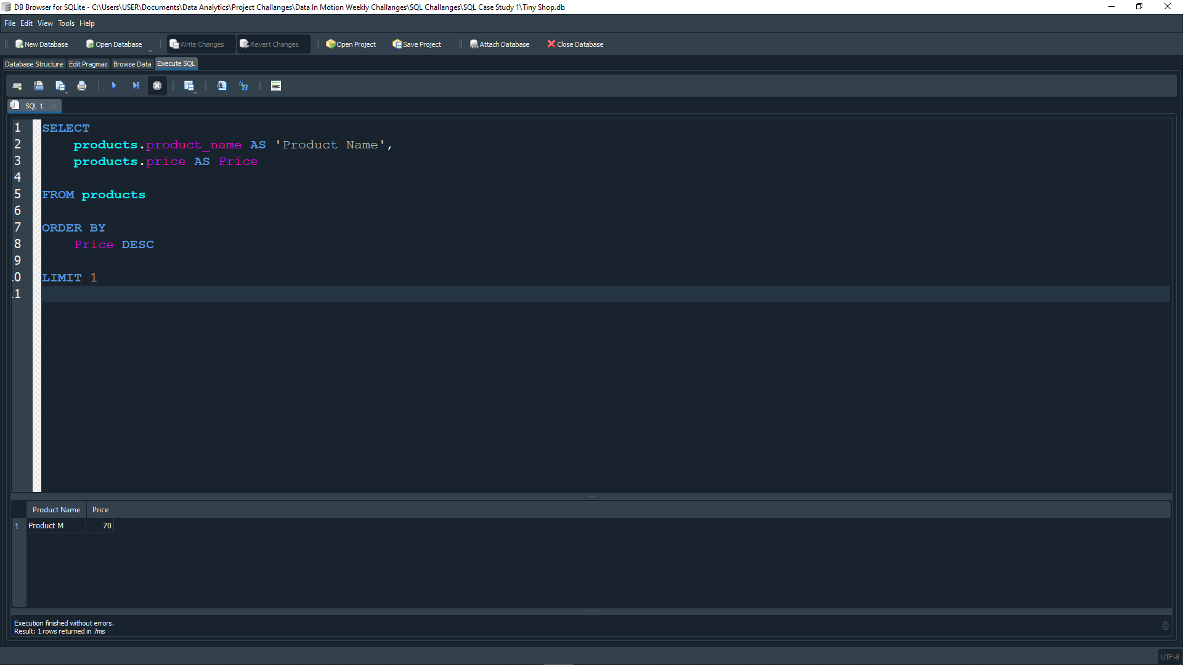

The product with the highest price is **Product M**, with the price of $70.

# **QUESTION 2: WHICH CUSTOMER HAS MADE THE MOST ORDERS?**

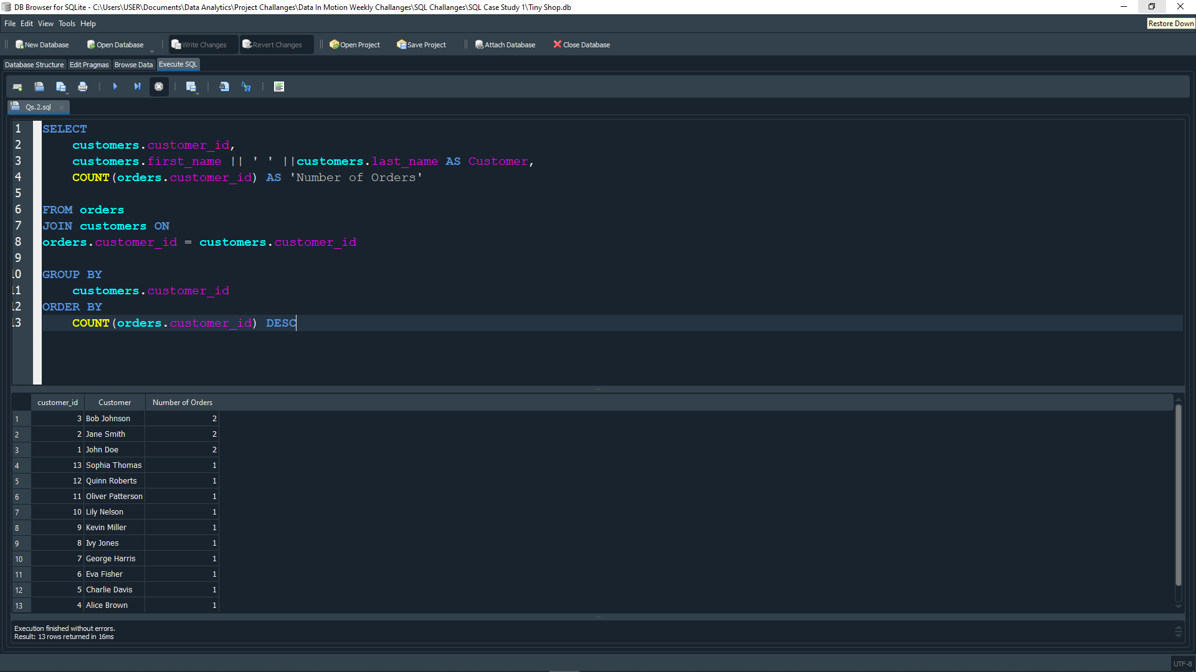

Customers with the greatest number of orders are:

1. **Bob Johnson**: 2
2. **Jane Smith**: 2
3. **John Doe**: 2

# **QUESTION 3: WHAT’S THE TOTAL REVENUE PER PRODUCT?**

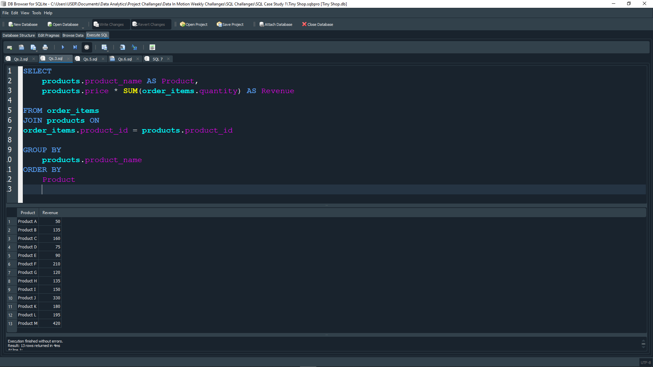

The total revenue for each product is:

1. **Product A**: $50
2. **Product B**: $135
3. **Product C**: $160
4. **Product D**: $75
5. **Product E**: $90
6. **Product F**: $210
7. **Product G**: $120
8. **Product H**: $135
9. **Product I**: $150
10. **Product J**: $330
11. **Product K**: $180
12. **Product L**: $195
13. **Product M**: $420

# **QUESTION 4: FIND THE DAY WITH THE HIGHEST REVENUE?**

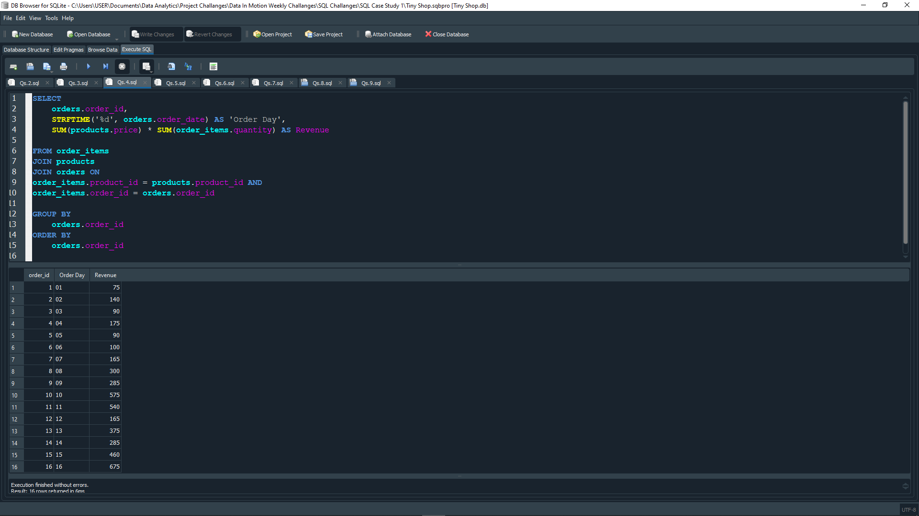

The day with the highest revenue is **Day 16**.

# **QUESTION 5: FIND THE FIRST ORDER (BY DATE) FOR EACH CUSTOMER.**

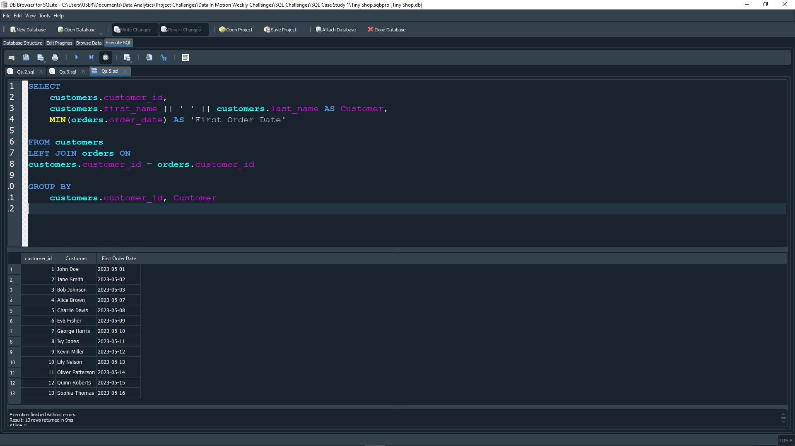

The first order date for each customer is:

1. **John Doe**: 2023-05-01
2. **Jane Smith**: 2023-05-02
3. **Bob Johnson**: 2023-05-03
4. **Alice Brown**: 2023-05-07
5. **Charlie Davis**: 2023-05-08
6. **Eva Fisher**: 2023-05-08
7. **George Harris**: 2023-05-10
8. **Ivy Jones**: 2023-05-11
9. **Kevin Miller**: 2023-05-12
10. **Lily Nelson**: 2023-05-13
11. **Oliver Patterson**: 2023-05-14
12. **Quinn Roberts**: 2023-05-15
13. **Sophia Thomas**: 2023-05-16

# **QUESTION 6: FIND THE TOP 3 CUSTOMERS WHO HAVE ORDERS THE MOST DISTINCT PRODUCTS?**

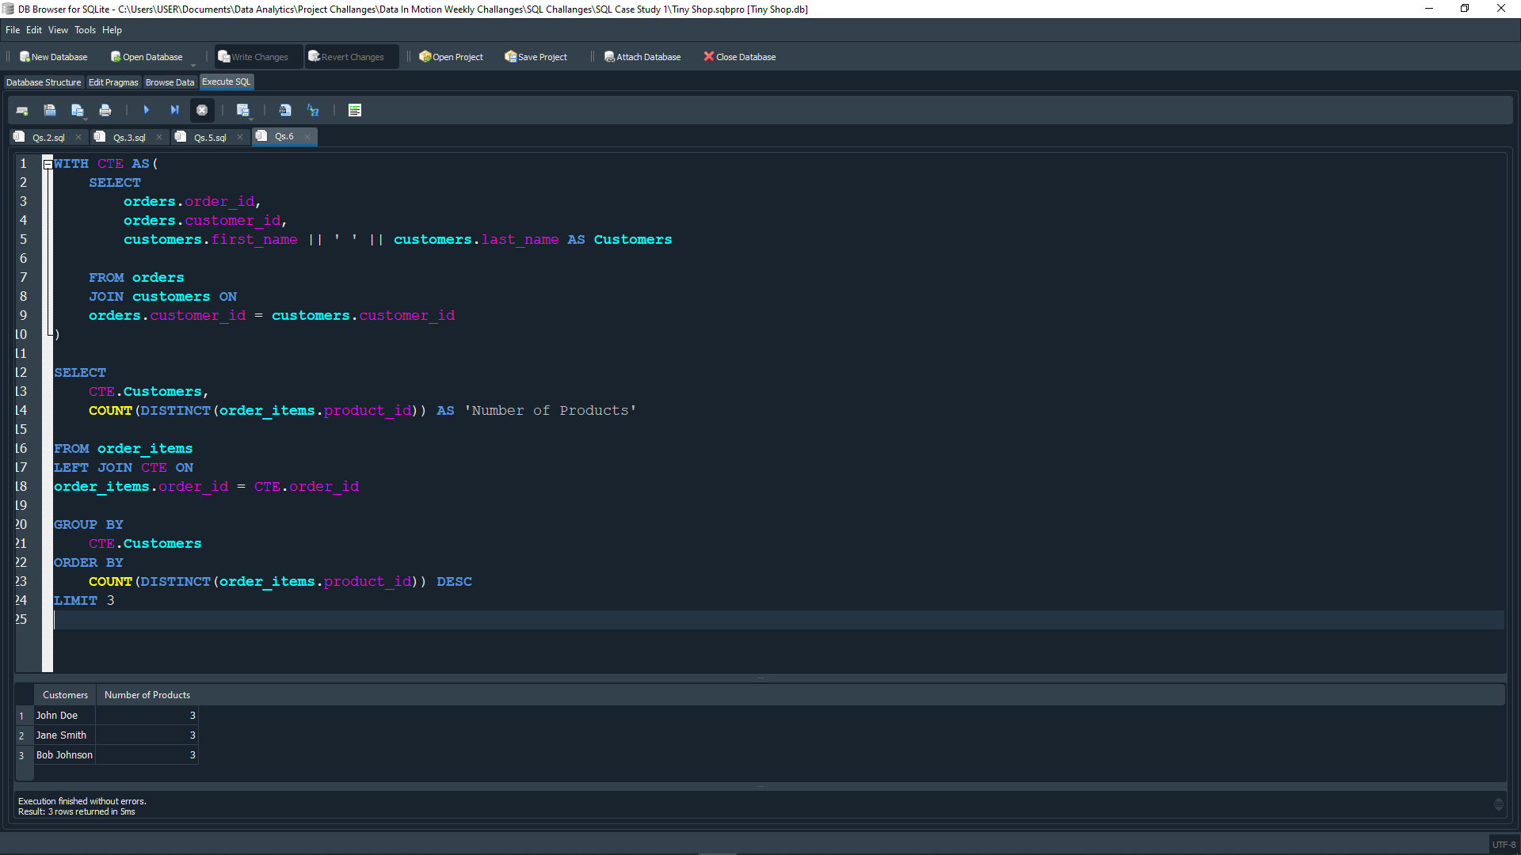

The top 3 customers who have ordered the most distinct products are:

1. **John Doe**: 3
2. **Jane Smith**: 3
3. **Bob Johnson**: 3

# **QUESTION 7: WHICH PRODUCT HAS BEEN BOUGHT THE LEAST IN TERMS OF QUANTITY?**

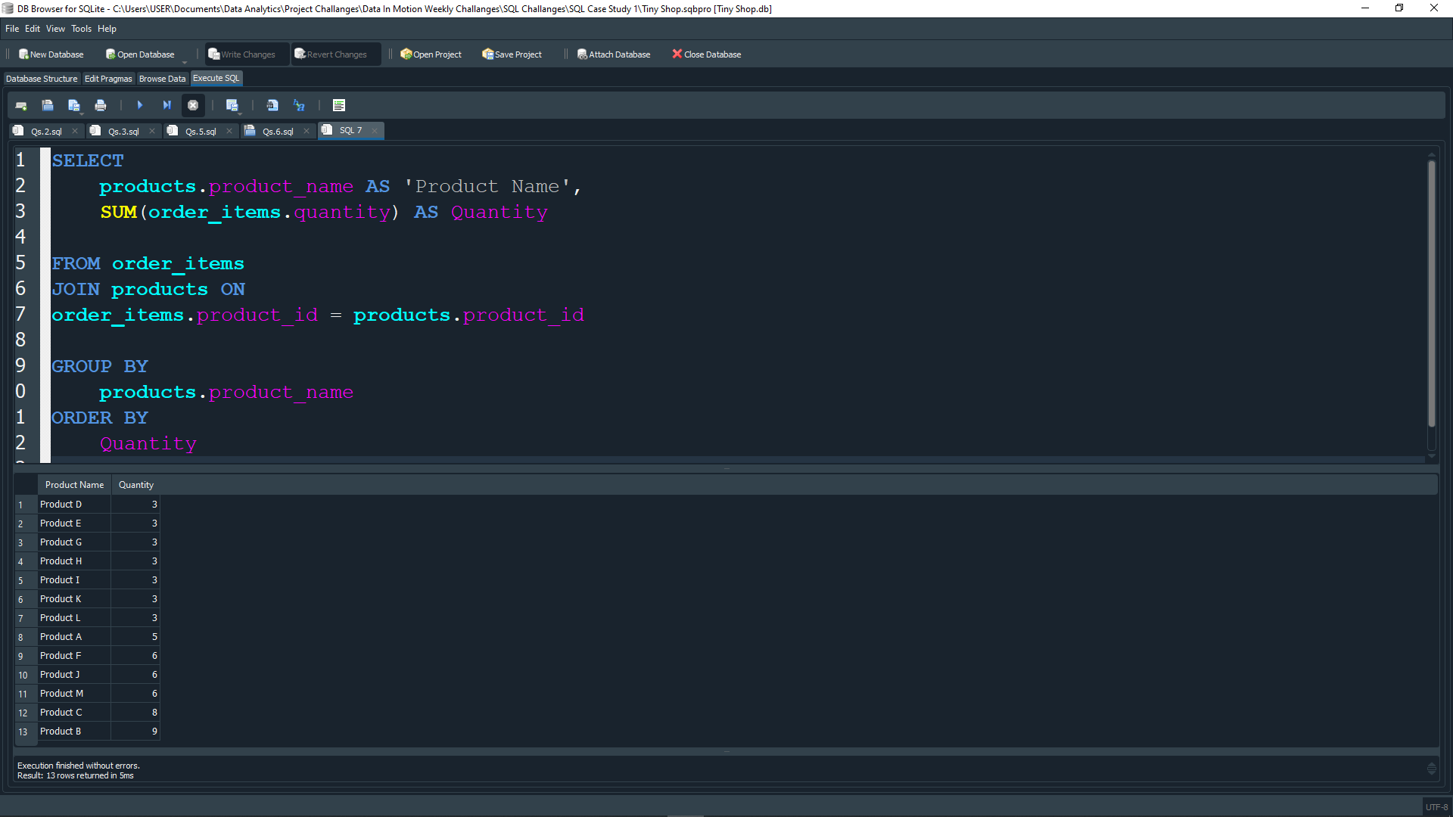

The products that have been bought the least in terms of quantity are:

1. **Product D**
2. **Product E**
3. **Product G**
4. **Product H**
5. **Product I**
6. **Product K**
7. **Product L**

All seven of them have a total quantity of **3**

# **QUESTION 8: WHAT IS THE MEDIAN ORDER TOTAL?**

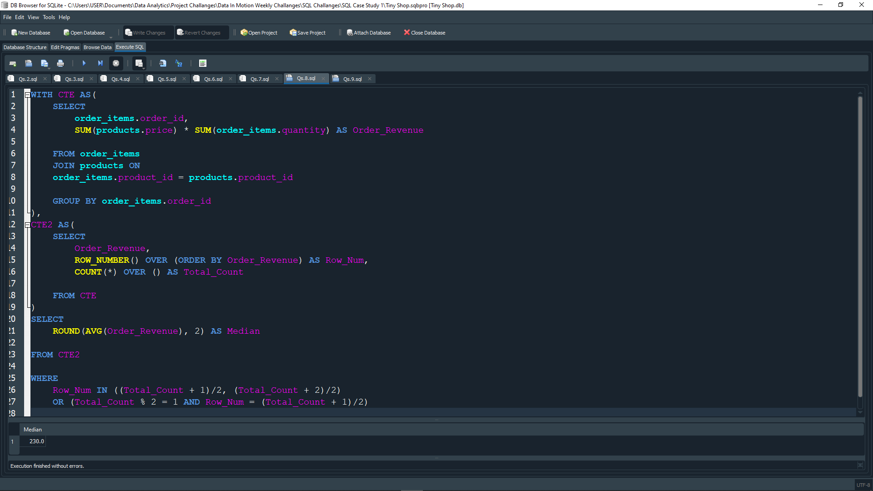

The median order total is **230.0**.

# **QUESTION 9: FOR EACH ORDER, DETERMINE IF IT WAS ‘EXPENSIVE’ (‘TOTAL OVER 300’), ‘AFFORDABLE’ (‘TOTAL OVER 100’), OR ‘CHEAP’.**

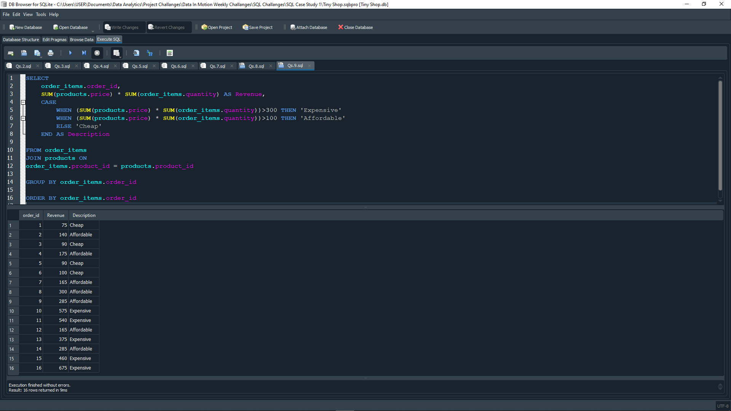

The results of determining if each order where either ‘expensive’, ‘affordable’ or ‘’cheap are:

1. **Order_id 1**: Cheap
2. **Order_id 2**: Affordable
3. **Order_id 3**: Cheap
4. **Order_id 4**: Affordable
5. **Order_id 5**: Cheap
6. **Order_id 6**: Cheap
7. **Order_id 7**: Affordable
8. **Order_id 8**: Affordable
9. **Order_id 9**: Affordable
10. **Order_id 10**: Expensive
11. **Order_id 11**: Expensive
12. **Order_id 12**: Affordable
13. **Order_id 13**: Expensive
14. **Order_id 14**: Affordable
15. **Order_id 15**: Expensive
16. **Order_id 16**: Expensive

# **QUESTION 10: FIND THE CUSTOMERS WHO HAVE ORDER THE PRODUCT WITH THE HIGHEST PRICE.**

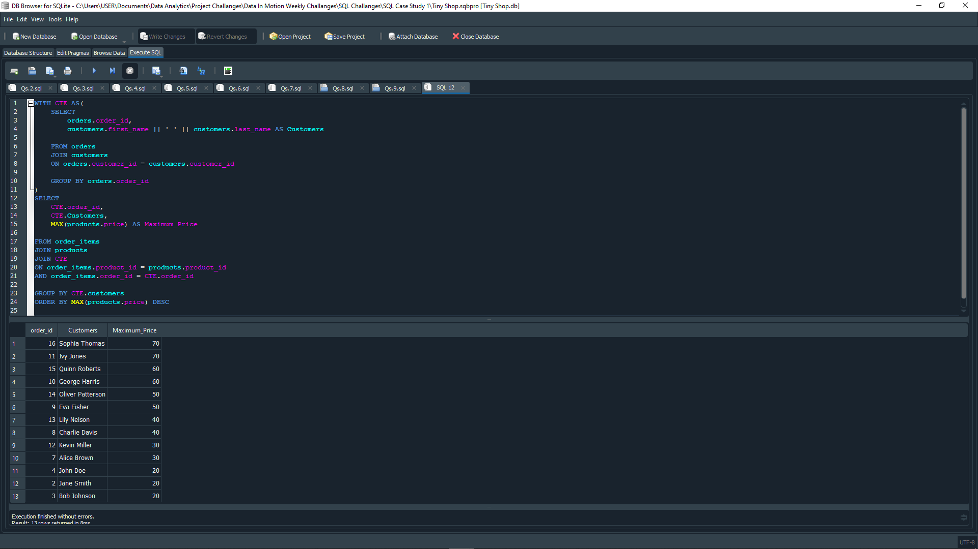

The customers who have orderd the product with the highest price are:

1. **Sophia Thomas**: $70
2. **Ivy Jones**: $70